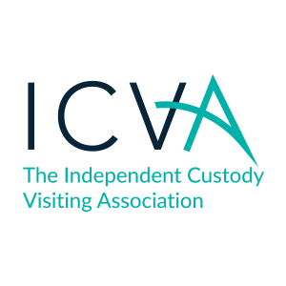
ICVA National Report Form
A user guide

The national report form has been developed by ICVA in conjunction with a scheme and trialled prior to launch. Schemes have requested that ICVA produce more standardised documents. This user guide is designed to go alongside of the form until ICVs are confident with its use.

Key for abbreviations

C & YP Children and Young People
Gender F / M / O Female, Male, Other
Ethnicity Please use codes as identified by the custody staff
AA Required Y/N Appropriate Adult required
Vulnerable MH / LD Vulnerable Mental Health / Learning Difficulties

When you arrive in custody

The tick boxes on the left of the form are to be completed with information from the custody staff prior to speaking to detainees.

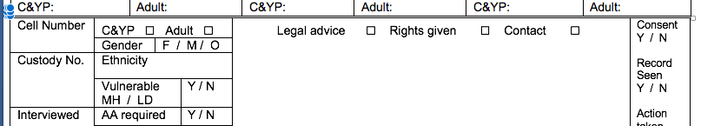

During your visit

Please check that the detainee has had a copy of their rights given, that they have received the offer of legal advice and that someone is aware of their detention if they wish them to know. If all 3 of these rights are fulfilled tick the boxes to indicate they have been done.

If any of these rights have not been completed, please note in the space provided. Where the rights have all been given, please use the space provided to record notes on detainee wellbeing, and anything else pertinent to your visit. Please try not to record simply no concerns, remember that ICVs can record good practice as well as causes for concern.

There are insert sheets for additional detainees.

There is a place at the end of the form to record matters brought to the attention of custody staff and actions taken to resolve it. There is also space to record the physical aspects of the suite and your visit with a checklist and space for free comment.

The form also includes space for you to record issues that need to be fed back to the Office of the Police and Crime Commissioner.

