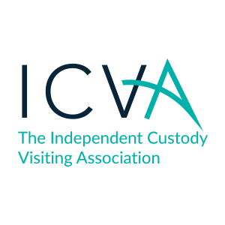
Detainee Dignity and Nudity
A briefing for ICVs
May 2018

Background to the briefing:

ICVA reviews all joint inspectorate reports on police custody (from 2015 to present day). The inspectorates frequently report that detainees of both genders are unjustifiably left naked or inappropriately clothed, compromising their dignity and mental wellbeing. This is not acceptable within police custody. ICVA has reviewed 29 inspectorate reports from 2015 – 2017 (incl) to investigate the nature and scope of the potential problem.

Evidence Base

Inspections methodology dictates that inspectors will only see a snapshot of custody for the time that they are present in suites and review some CCTV therefore the scale of the issue is unknown. The main areas of concern from the reports are as follows:

- Leaving detainees naked in cell (no less than 8 instances)
- Clothing removal and/or strip searches taking place with members of opposite gender present (approx. 13 reports)
- Clothing removal and/or strip searches taking place able to be viewed on CCTV
- Removal of clothes and placing detainees in anti-rip clothing inappropriately

Of the 29 reports inspectorate reports viewed, ICVA has identified issues in one of the areas above in 24 of these reports to varying degrees.

All detainees must be treated with dignity and respect whilst in police custody. It does not matter how a detainee is behaving or why they may be there, ICVs must observe and report on the wellbeing and treatment of detainees, and question anything they feel is not right.

Custody Visiting Schemes Response

A survey ICVA conducted with schemes suggested that where detainees were naked, ICVs have been informed that they have removed their own clothes in most cases and gave a variety of methods of checking the wellbeing of these detainees. Schemes noted in their responses that some national guidance regarding this issue would be welcomed. Inspectorate reports indicate that clothes are being removed by force or withheld for reasons of harm minimisation. This disparity in the reasons for nudity of detainees has led to ICVA undertaking some further work in this area and producing this briefing for ICVs.

What does the legislation/guidance say?

PACE at present does not cover this issue specifically however, ICVA are working with the Home Office to include some wording in the legislation covering detainee dignity to enhance the legislation in this area.
What should scheme managers do?

- Please disseminate the ICV briefing to your panels and allow time for discussion at a panel meeting if needed to run through it.
- Reassure ICVs that they are not being asked to view naked detainees.
- Reassure ICVs that these issues are simply something to be aware of and record where seen
- Encourage ICVs to make a note of naked detainees/anti-rip suits if they are able including notes on treatment if possible
- Please look at the reports you receive that contain nudity and or anti-rip suits
- When receiving reports which contain the above – please let ICVA know on info@icva.org – this can be for good practice or recorded concerns. Please do not wait for quarterly returns to feedback on this specific area.

