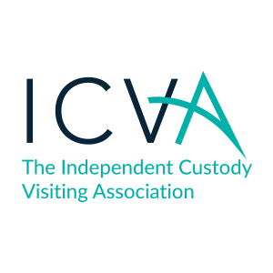
Appropriate Adult and ICV Dual Roles

Advice from the Home Office via ICVA

Background
Currently ICVs are able to act as both ICVs and AAs.
This means that although they cannot act in the two roles simultaneously, a person can hold both roles simultaneously. Under the current rules:
• an ICV at a station can simply cease acting in that capacity and begin acting as an AA (simply by walking out and then back in again);
• a Police and Crime Commissioner can operate a single team of volunteers carrying out both the ICV and AA role in the same area.
Issues with people holding both roles
“Once you start becoming part of the process then you cannot credibly independently inspect something that which you have helped to create or been part of.”
- Dame Anne Owers (in evidence to the Justice Select Committee)
There is a scarcity of accountability in relation to appropriate adults. Reporting and governance is typically restricted to remote contract management focusing on activity and output measures (such as the number of call outs and response times). There is insufficient consideration of outcomes for vulnerable suspects or their views on the quality of provision.
ICVs are uniquely positioned to contribute to this space, subject to them remaining independent of provision of services within the custody environment.
It is not possible to independently inspect something which one is involved in providing. This applies even where the ICV is not acting as an AA simultaneously as they will necessarily be inspecting the work of colleagues, who in turn will inspect them on another occasion.
Update

ICVA has therefore consulted with schemes and those who responded were largely supportive of separating the roles due to the reasons outlined above (and some schemes already have this in place).

NAAN have consulted and are launching their new National Standards, and the new standards includes AAs not also acting as ICVs and separating the roles. The PACE Strategy group also voted unanimously in support of this move in Feb 2018.

Therefore, we would recommend that schemes adopt the paragraph below in their local recruitment information/policy with immediate effect for all future recruitment.

Schemes may wish to give consideration to a lead-in time for those who currently dual role to choose one role or the other depending on interest and alert volunteers as to when such a choice might need to be made.

Draft Policy

New applications from interested custody visitors will not be accepted if they are currently an appropriate adult in the same area. This is due to a conflict of interests in the two roles, as custody visitors may, on occasion, have cause to give critical feedback regarding the provision of appropriate adult services in the area they visit. Therefore, the independence element of the custody visitor role precludes one person covering both ICV and AA roles in a suite.

Exceptions
ICVs may act as an AA if:
• in relation to a child, they are the parent or guardian; or
• in relation to a vulnerable adult, they are a relative, guardian or other person responsible for their care or custody.
Report Ends.

