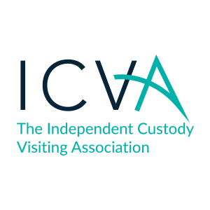
Appropriate Adults
ICV Checklist

The Appropriate Adults, (AA), is a statutory role established by PACE 1984 and its Codes of Practice, a framework that applies to police forces in England, Wales and Northern Ireland. The role’s origins lie in a miscarriage of justice in which two children and a young adult with a learning disability were convicted of serious offences on the basis of false confessions.
The below represents a brief checklist for ICVs when carrying out visits to this group of detainees. ICVs may also wish to consider if all detainees in the suite who could be vulnerable have been considered as requiring an ICV, and reasons for not requesting an AA where thought not necessary have been recorded.

When you arrive in custody
- Prioritise visits to children or vulnerable adults.

During your visit
- If the detainee is a child or vulnerable adult, check that an AA has been requested and that they have attended, making note of repeat visits.
- Check on rights, entitlements and wellbeing as you would for any visit.
- If, during your conversation you think a detainee is vulnerable, ask if they have had an AA.
- Ask the detainee if you are able to check the custody record.

When looking at the custody record (with permission)
- Check to see if an AA was requested for all children and vulnerable adults.
- Check to see if when an AA was not requested for an adult that could be considered vulnerable, that the rationale for custody staff not requesting an AA is fully recorded.
- Check what time an AA was requested.
- Check what time the AA arrived in custody.

When completing your report
- Report on rights, entitlements and wellbeing as normal.
- Check that the detainee has had access to an AA and knows what an AA is there for.

If you have had access to the custody record:
- Note rationale for custody staff requesting/not requesting an AA.
- Report on what time the AA was requested.
- Note what time the AA arrived and if they were present for rights and entitlements, DNA and fingerprinting, a private conversation and interview.

Scheme managers
- Please highlight any problems, themes or strengths to your PCC.
- Please report themes and issues to ICVA as part of your quarterly report.

